**Day 3 Assignment 3: Agile Methodology**

Agile methodology is a project management approach that allows successful and efficient execution of the project while emphasizing the improvement of a project and team collaboration. The approach is applicable in software development for flexibility, customer satisfaction, and collaboration.

**Requirements:** The companies here gather information on customer’s requirements and prioritize them based on different factors. It is an initial factor to understand the direction of the project and progress.

**Planning:** Developing a plan is an essential part of delivering the complete software comprising all the features. The plan includes time for the development and delivery of each iteration.

**Development:** The software development is carried out by the development team while using frequent and rapid iterations.

Testing: It involves software testing to make sure it meets the quality delivered by the organization and expected by the customer

**Deployment:** Here, the organization serves the ultimate aim, which is to allow usage of the software.

**Maintenance:** The software is regularly maintained to ensure customers' needs and expectations are met.

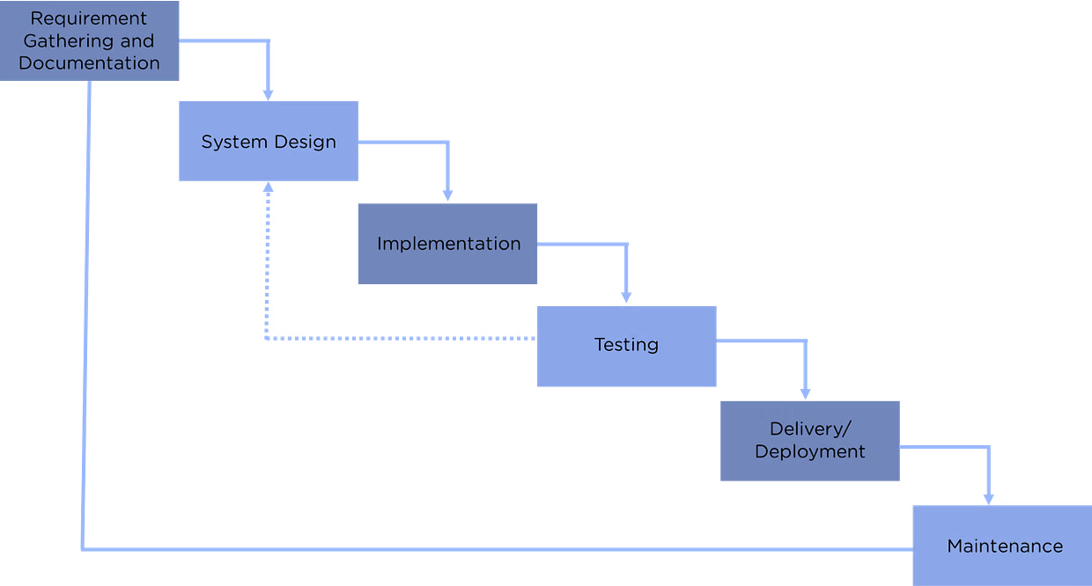

**Principles of Agile Software Development Methodology**

There are 12 agile principles mentioned in the Agile process. Agile principles are guidelines for flexible and efficient software development. They emphasize frequent delivery, embracing change, collaboration, and continuous improvement. The focus is on delivering value, maintaining a sustainable work pace, and ensuring technical excellence.

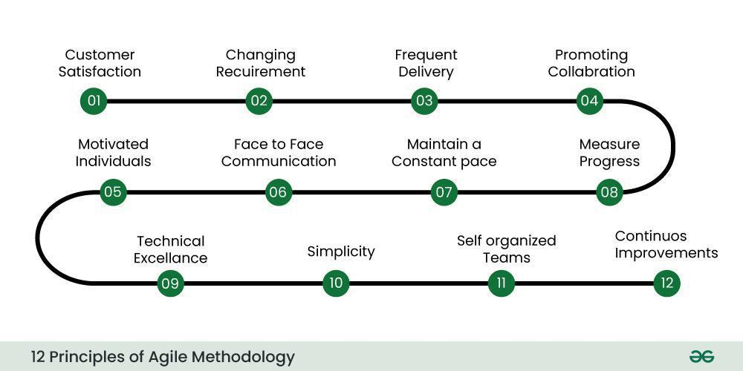

The Agile Alliance defines twelve lightness principles for those who need to attain agility:

**1**.Our highest priority is to satisfy the client through early and continuous delivery of valuable computer software.

**2**.Welcome dynamic necessities, even late in development. Agile processes harness modification for the customer’s competitive advantage.

**3.**Deliver operating computer software often, from a pair of weeks to a couple of months, with a preference to the shorter timescale.

**4**.Business individuals and developers should work along daily throughout the project.

**5.**The build comes around actuated people. offer them the setting and support they have, and trust them to urge the task done.

**6**.The foremost economical and effective methodology of conveyancing info to and among a development team is face-to-face speech.

**7.**Working with computer software is the primary life of progress.

**8.**Agile processes promote property development. The sponsors, developers, and users will be able to maintain a relentless pace indefinitely.

**9**.Continuous attention to technical excellence and smart style enhances nimbleness.

**10.**Simplicity—the art of maximizing the number of work not done—is essential.

**11**.the most effective architectures, necessities, and styles emerge from self–organizing groups.

**12.**At regular intervals, the team reflects on a way to become simpler, then tunes and adjusts its behavior consequently.

**Advantages of Agile Software Development**

* People and interactions are preferred over tools and processes in the usage of Agile software development methodology.
* It leads to a regular focus on improved design and technical excellence.
* The Agile development process  assists in improvement by allowing immediate feedback.
* Fastens the software development process, thus increasing customer trust.
* Allows quick adaptability to meet the change in requirements.
* Incorporates flexibility and adaptability.
* Enhances quality and reliability through a focus on quality assurance and continuous improvement.
* Increase team confidence and allow the set up of a collaborative, positive, and supportive workplace culture.

**Disadvantages of Agile Software Development Life Cycle**

* Agile development is linked with lesser documentation and a higher focus on codes.
* Agile software development depends on continuous iteration and feedback from customers, leading to difficult estimation of timelines, outcomes, and budgets of projects.
* Understanding the quantity and intensity of effort required for project completion is challenging at an early stage of the Agile software development lifecycle.
* Dependency on the customer leads to wrong progress in the project if the team encounters ambiguity.
* It is difficult for new programmers to adapt to the workplace environment as the senior programmers make most decisions.
* Higher flexibility and adaptability can also lead to scope creep and lack of control over project scope.
* The swiftness of Agile development with high intensity, more number of sprints, and close deadlines lead to mental exhaustion and increased pressure on team members, further leading to burnout.
* Agile development lacks the structure compared to other methodologies, which results in oversight and poor governance.

**Conclusion:**

Agile principles provide a foundation for a flexible and efficient software development process. By emphasizing frequent delivery, embracing change, and fostering collaboration, Agile processes enable teams to adapt incrementally and sustain progress. Continuous improvement, technical excellence, and a sustainable work pace are key aspects of this methodology.